Please run ‘platemo.m’ to open the PlatEMO platform. Locate and select the MMOCHT algorithm and the ORPD_bus30 problem. Then, click the Start button to execute the program.

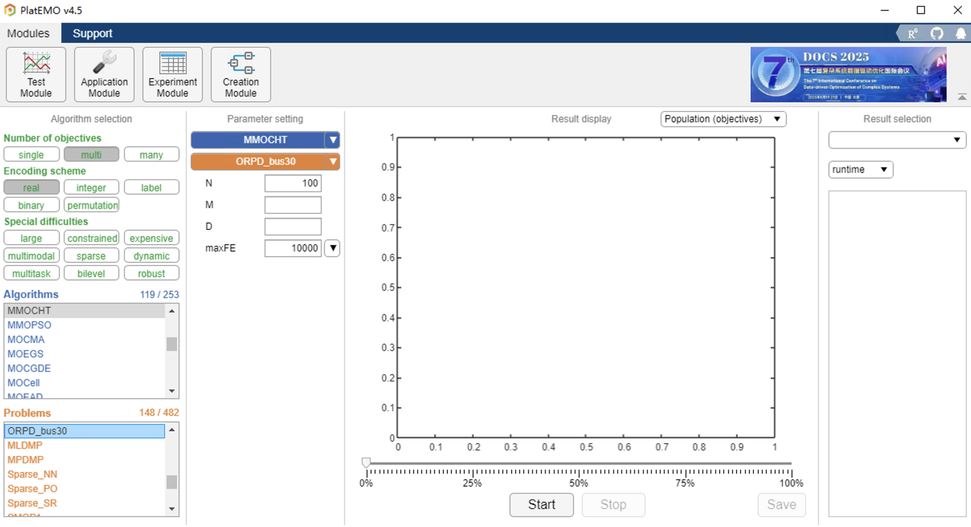

After the program completes execution, please save the results as an Excel file. In the saved results: Columns A-L correspond to control variables, Columns M-N to objective variables, and the remaining columns to constraint variables. These results can be used to generate the figures in the manuscript. If you encounter any issues during use, please feel free to contact me.

